Big Data Lab

Steps To Run on Docker

**Installing docker if not exists:**

1. Check if docker already exists:

sudo docker *--version*

1. If not installed install it by following steps:

sudo apt-get **update**

|  |
| --- |
| echo \  "deb [**arch**=$(dpkg --**print**-architecture) signed-**by**=/usr/share/keyrings/docker-archive-keyring.gpg] https:*//download.docker.com/linux/ubuntu *  $(lsb_release -**cs**) stable" | sudo tee  /etc/apt/sources.**list**.**d**/docker.**list** > /dev/null |

sudo apt-get **update**

sudo apt-get install docker-**ce** docker-**ce**-cli containerd.io

**Pull image and run:**

docker run -**it** adityasm1238/cclab:2.2

Once inside the container to start all the data nodes and name nodes run:

start-nodes

Wait until hadoop **safemode** is turned **off**

Status of safe mode can be checked using following command:

hdfs dfsadmin -safemode **get**

**To run hive:**

Once the safe mode is off, run the following command to open hive shell:

run-hive

**To run hbase:**

Once the safe mode is off, run the following command to open hbase shell:

hbase shell

Then inside hbase shell try running :

status

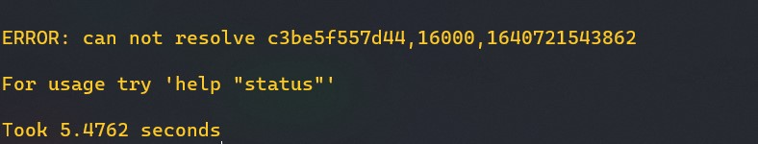

Wait until the above command stops giving error, this happens because the hbase nodes take approx 3 min to start.



It means hbase is up and running.

**To run pig:**

Once the safe mode is off, use ‘nano’ to edit and save the program along with data file, Run the program by using:

pig -x local program_name.pig

**To run hadoop:**

Write all programs, and data files using nano, Once the safe mode is off, put the data files into hdfs:

hdfs dfs -put /path/to/file/in/local /

To check if files are present in hdfs:

hdfs dfs -ls /

To export classpath run the following command to get classpath value

hadoop classpath

Copy paste the value in class path variable:

export CLASSPATH=<copied_value>

Compile the programs:

javac *.java -d .

Create **Manifest.txt** file using nano and make jar file:

jar cfm filename.jar Manifest.txt packagename/*

Once the jar is created, before running confirm there is no previous output folder in hdfs if present delete it using:

hdfs dfs -rm -r -f /output

To run jar:

hadoop jar filename.jar /datafile.csv /output

To check output:

hdfs dfs -cat /output/*